Simple key to important thrips pests of Canadian greenhouses

Who is this Key Designed For?
This key was designed for use by growers of, and IPM practitioners in, greenhouse floriculture and vegetable crops in Canada.
What is the Purpose of this Key?
For greenhouse growers/IPM practitioners to easily and properly identify species of thrips infesting their crops without necessitating the use of outside identification services.
Proper thrips identification is important because A) the presence of some thrips species can threaten exportation of plant material (i.e. Chili thrips), and B) effective control measures can vary considerably by species. For example, onion thrips and chrysanthemum thrips are both susceptible to Success (spinosad), while western flower thrips is not. On-site identification means that proper control or eradication measures can be implemented more quickly.
Collecting Thrips for Identification:
Collect thrips using plant taps from multiple areas (randomly selected) to get a picture of the entire thrips population in your greenhouse, or from specific areas of concern. Thrips can be tapped directly into a shallow container of soapy water to kill them. Or, thrips can be tapped into a container with a lid, which can be placed in the freezer for at least 30 min to kill the thrips.
Thrips are easiest to examine under the microscope when dead, but not dried out. Therefore, samples should be identified within the next 48h after collection so the samples do not desiccate.
How to Use this Key:
All features used in this key can typically be seen using a mid-quality dissection microscope. Your microscope will need to have a maximum magnification level of at LEAST 45X. To determine the maximum level of magnification on your microscope, take the highest number on the adjustable magnification dial (e.g. 4.5) and multiply it by the magnification of the eyepiece (usually 10X).
For each numbered step (1-6), pick one of the two possible choices that most resembles your specimen. This will indicate the species OR the next step you should jump to.
For proper identification, ADULT (i.e. winged) thrips must be used. Position the thrips stomach side down so that the wings are facing up, with the head facing away from you. This is often easier to do with a small probe or fine paintbrush with the thrips floating in water (or 70% alcohol) in a Petri dish or other small clear container. Look at multiple specimens (minimum of 20) to confirm your identification for an infestation on a specific crop. To get a wider picture of your greenhouse population, at least 100 thrips should be identified
NOTE: This key is NOT comprehensive for all thrips species that may occur in Canada (or than can be imported on plant material), but includes those most likely to be encountered in floriculture and/or vegetable greenhouses. If proper species identification is in doubt, please contact an OMAFRA IPM extension specialist, or the National Identification Service.
Who Was This Key Designed by?
This key was a collaboration between Dr. S. Jandricic at the Ontario Ministry of Agriculture, Food and Rural Affairs (OMAFRA) and A. Summerfield at the Vineland Research and Innovation Centre in consultation with Eric Maw of the Canadian National Collection of Insects, Arachnids and Nematodes.
How to cite this key:
Summerfield, A. and Jandricic, S. 2018. Simple key to important thrips pests of Canadian greenhouses. GreenhouseIPM.org/pests/thripskey

Where to find more information:
If you are looking for more detailed keys or those that cover more species, there are several keys available online:
http://journals.fcla.edu/flaent/article/view/87973
https://content.ces.ncsu.edu/insect-and-related-pests-of-flowers-and-foliage-plants/thrips-in-the-greenhouse
https://keyserver.lucidcentral.org/key-server/player.jsp?keyId=26&thumbnails=true

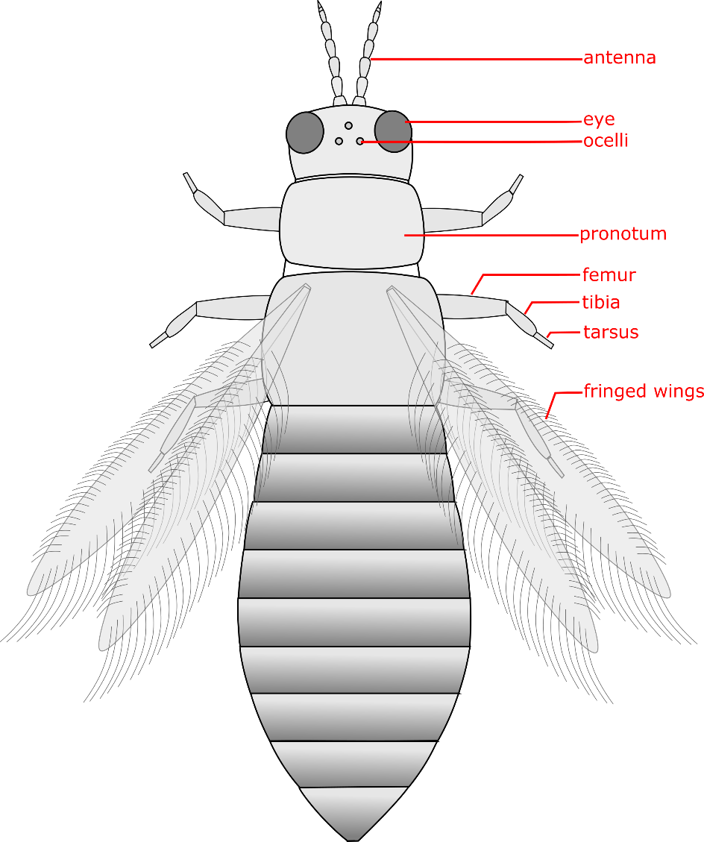
Figure 1. General anatomy of a thrips and important anatomical features used for identification in this key.

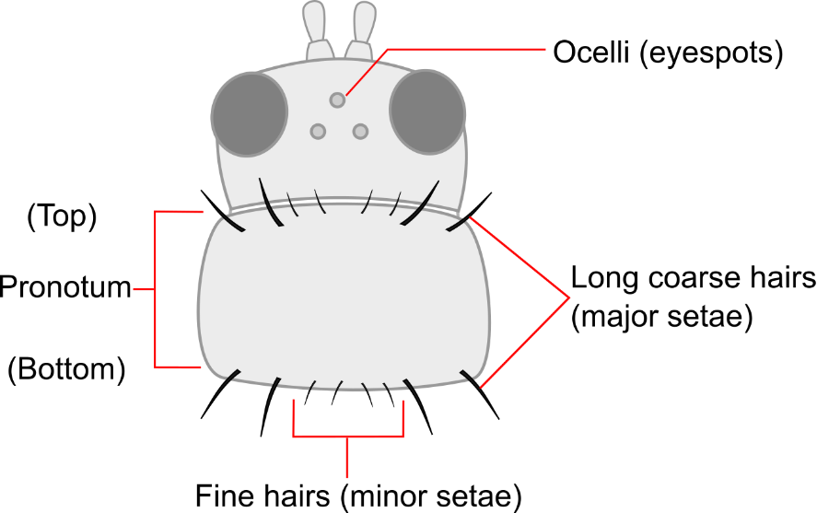

Figure 2. Close-up of features on the head and pronotoum.
- a) body pale, yellow, tan, or light brown in colour ………….……..GO TO STEP 2
b) body mostly dark-brown to black in colour ………………….……GO TO STEP 6
2.
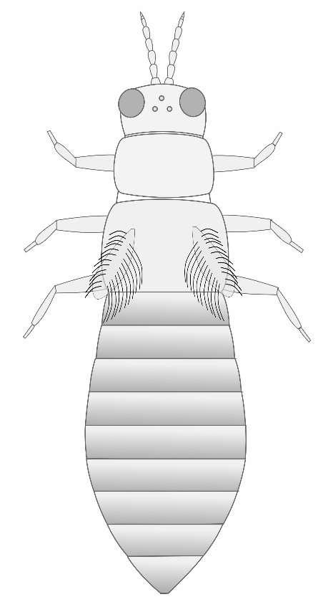 | 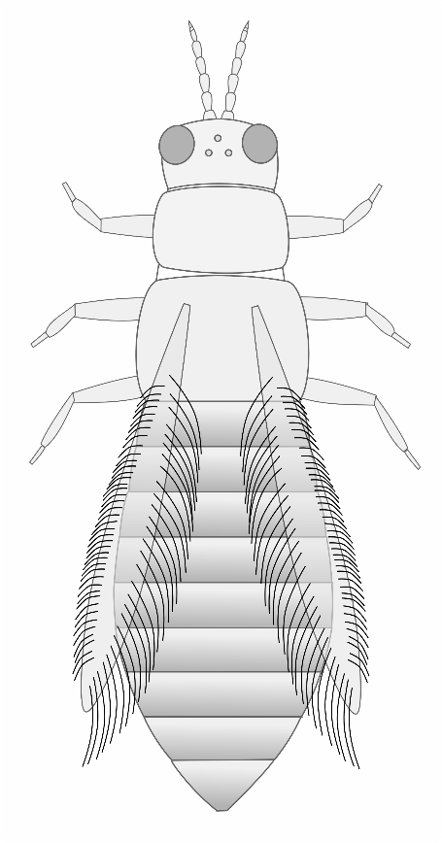
a. Very short wings, shorter than the width of the body; usually only found on chrysanthemums and gloxinias; Chrysanthemum thrips (Thrips nigropilosus) | b. Long fringed wings extending nearly the full length of the body;  (GO TO STEP 3)

3.
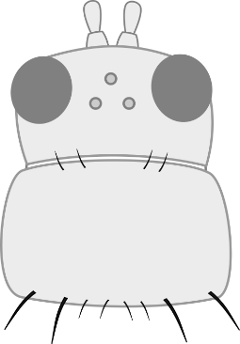 | 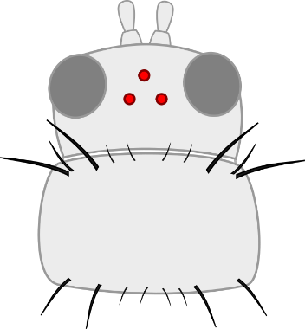
a. No long coarse hairs on the top of pronotum; ocelli may or may not be red (GO TO STEP 4) | b. Top of pronotum has 2 pairs of long coarse hairs that are roughly equal in length; ocelli are red; most likely Western Flower Thrips (Frankliniella occidentalis) *
* In Ontario greenhouses, the vast majority of thrips you are ever likely to encounter will be Western Flower Thrips. However, they closely resemble Common blossom thrips and Eastern flower thrips. To better differentiate these species, go to step 5.

 | 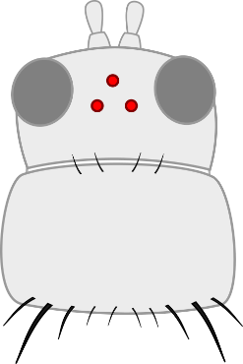
a. Ocelli grey; 2 pairs of long coarse hairs on the bottom of the pronotum: Onion thrips (Thrips tabaci) | b. Ocelli red; 1 pair of distinctly longer coarse hairs on the bottom of the pronotum; small body size compared to other thrips species; usually found on tropicals: Chilli thrips (Scirtothrips dorsalis)

5. * These features may not be visible using a dissection microscope, and a compound microscope may be required.
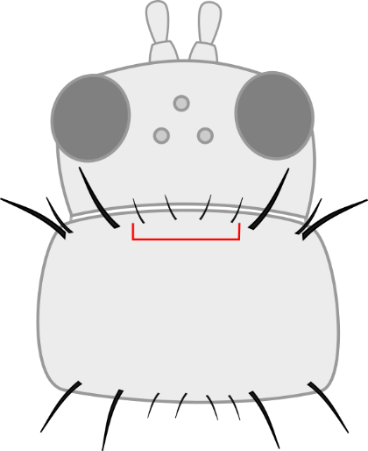 | 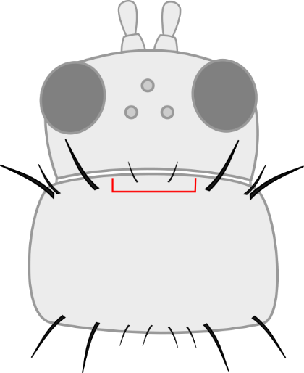
a. Four fine hairs on the top of the pronotum between two major setae; Western Flower Thrips (Frankliniella occidentalis) | b. Only two fine hairs on top of pronotum between two major setae; either Eastern Flower Thrips (F. tritici), Common blossom thrips (F. schultzei), or Florida Flower thrips (F. bispinosa); send to OMAFRA IPM extension specialist or National Identification Service for species identification.

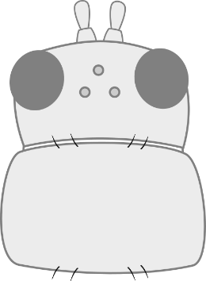 | OR 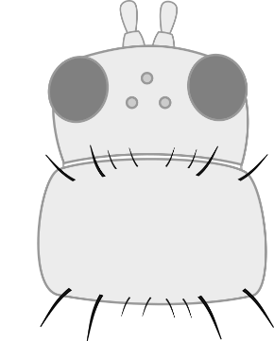
a. Pronotum has no long coarse hairs (GO TO STEP 7) | b. Pronotum has long coarse hairs  (GO TO STEP 8)

7.
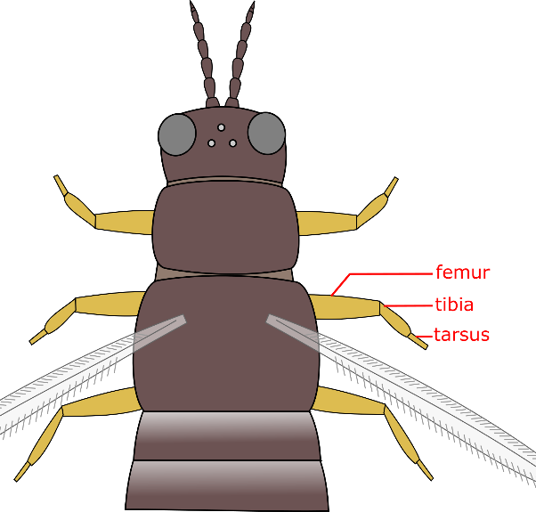 | 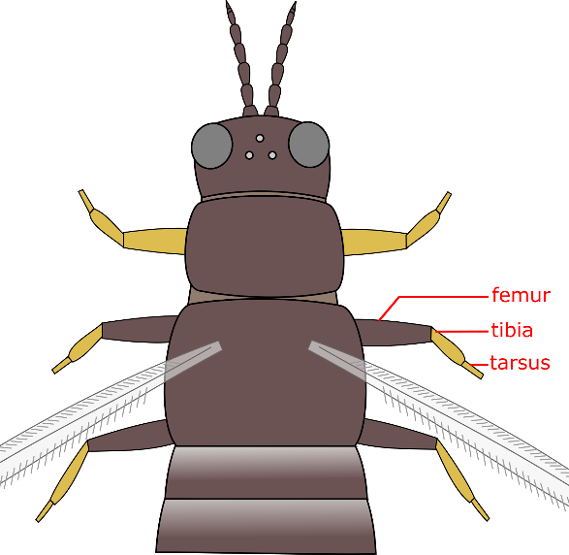
a. Legs entirely yellow: Greenhouse thrips (Heliothrips haemorrhoidalis) | b. Legs yellow with brown femurs: Banded greenhouse thrips (Hercinothrips femoralis)

8.
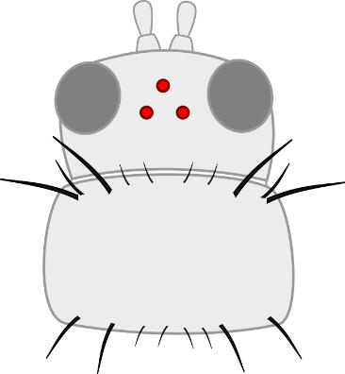 | 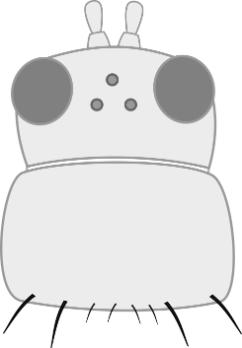
a. Pronotum has long coarse hairs on BOTH top and bottom of pronotum: most likely Western Flower Thrips, dark morph (Frankliniella occidentalis)* | b. NO long coarse hairs or fine hairs on the top of pronotum; bottom has 2 pairs of long coarse hairs: Echinothrips (aka Poinsettia thrips) (Echinothrips americanus)

